Three Games

1)
Nim – a game for two players
There is a pile of 18 counters on the table. Players take turns to remove counters. Each player can remove 1, 2, 3 or 4 counters on each turn. The player who removes the last counter is the winner.
For example:
Eric takes 4 counters, Bill takes 2, Eric takes 3, Bill takes 4, Eric takes 3, Bill takes 2. Bill wins.
Jane has a good strategy to play this game. If Eric takescounters then Jane next takescounters so they have taken 5 counters between them.
We start with 18 counters. Jane goes first and takes 3 counters, leaving 15 counters.
15 is a multiple of 5. Now it is Eric’s go. Can you see why Jane will win?
Note: You can play this game with any number of counters at the start.
We start with 97 counters. Jane goes first and takes 2 counters, leaving 95 counters.
95 is a multiple of 5. Now it is Eric’s go. Can you see why Jane will win?
We start with 30 counters. Jane lets Eric go first. How nice of her. Can you see why Jane will win?
2)
Fifteen – a game for two players
We have nine cards numbered 1, 2, … 9. Players take turns to take a card. The first player who has taken three cards that add up to fifteen is the winner.
For example:
Eric takes the 4, Bill takes the 9, Eric takes the 6, Bill takes the 5, Eric takes the 3, Bill takes the 8, Eric takes the 2, Bill takes the 1. Bill holds the 9, 5 and 1. So Bill wins.
Jane has a good strategy to play this game. She has a magic square:
8 | 3 | 4
1 | 5 | 9
6 | 7 | 2

How will this help?
3)
A game for one player
A | B | C
D | E | F
G | H | I
Place white knights on squares A and C. Place black knights on squares G and I. Move the knights (in any order) so that the white knights end up on the squares G and I and the black knights end up on the squares A and C.
The diagram below shows which squares are connected by knight moves. So, for example, a knight can move from square F to square A or to square G. We could play the game on this diagram. It would be much easier. Can you see why?
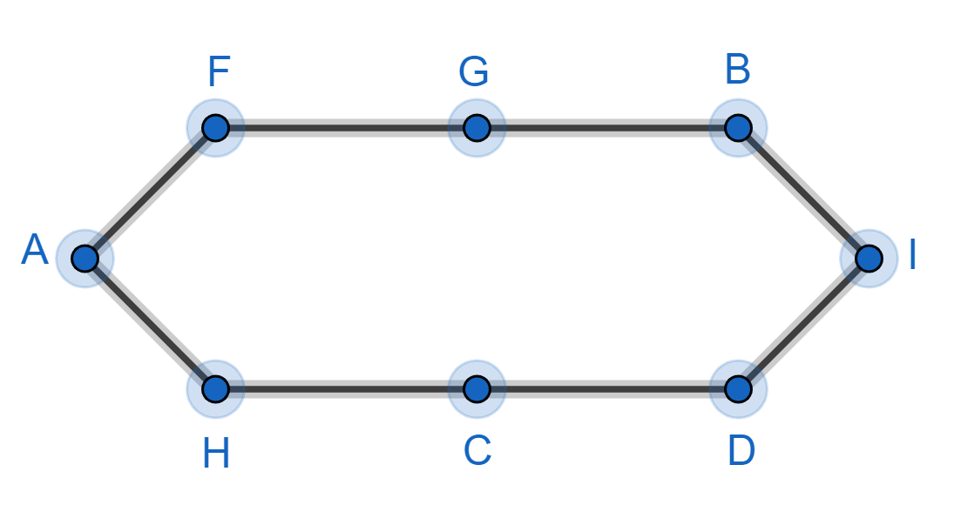

4)
A game for one player
A | B | C
D | E | F
G | H | I
J | K | L

Place white knights on squares A, B and C. Place black knights on squares J, K and L. Move the knights (in any order) so that the white knights end up on the squares J, K and L and the black knights end up on the squares A, B and C.
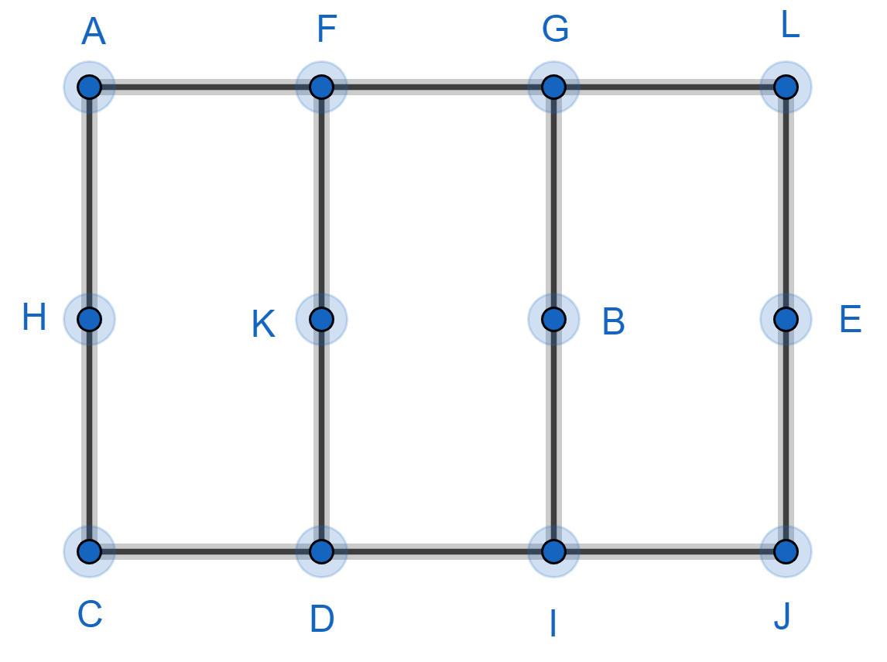
The diagram below shows which squares are connected by knight moves ...

